SAMYUKTHA RAJ-

PROGRESS REPORT[17/12/2018]-

Completed the first two out of the five courses on python(offered by University of Michigan) and finished week two of the third course and week three of the ML course(by Andrew NG). Relevant codes of the python course one are also attached.

CLASSIFICATION-

The classification problem is just like the regression problem, except that the values we now want to predict take on only a small number of discrete values.

HYPOTHESIS REPRESENTATION-

SIGMOID FUNCTION-

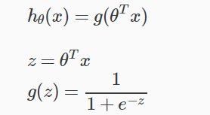

The function g(z), shown here, maps any real number to the (0, 1) interval, making it useful for transforming an arbitrary-valued function into a function better suited for classification.

*hθ*(*x*) will give us the **probability** that our output is 1.

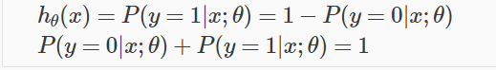

COST FUNCTION-

We cannot use the same cost function that we use for linear regression because the Logistic Function will cause the output to be wavy, causing many local optima. In other words, it will not be a convex function.

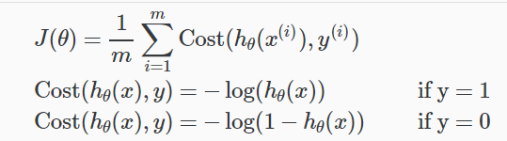

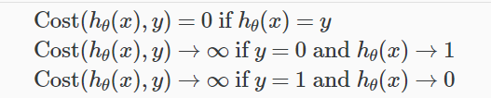

SIMPLIFIED VERSION-

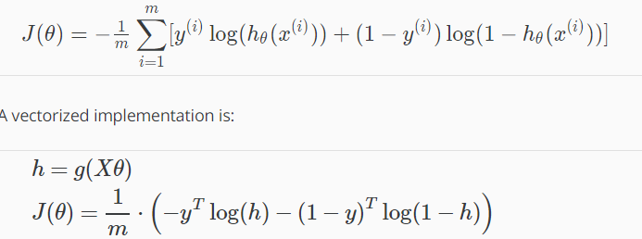

GRADIENT DESCENT-

